National Partnership on Low SES School Communities
Situational analysis report for
new schools with 2011 start date
November 2010
Induna School
5756
November 8 2010
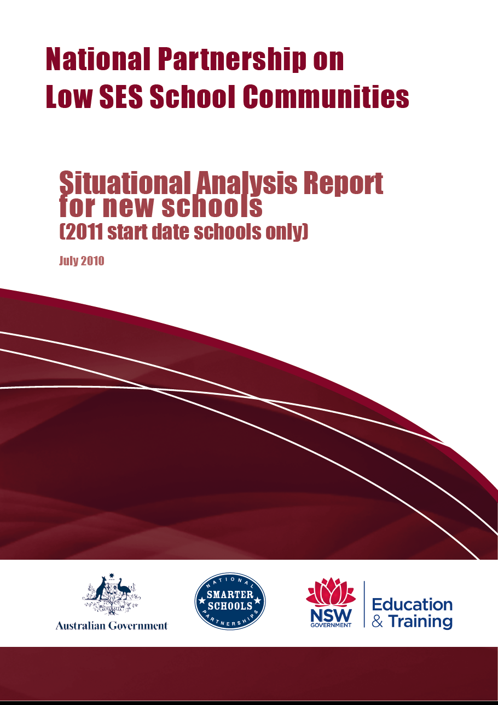
North Coast Region

NSW Department of Education and Training

The following is a report prepared as a result of a Situational Analysis at Induna School from August 2010.

- School situational analysis team members and position
Barry Principal
Jeff Head Teacher Learning Support
Alan Relieving Assistant Principal
Robert Literacy Coordinator
Michael Teacher
Grieg Teacher
Lesley Aboriginal Education Officer & Grafton Local AECG
Glen Parent Representative
Carolyn Parent Representative
Cheryl Parent Representative
Dennis Parent Representative

- Report authors, name and position
Barry Principal
Alan Relieving Assistant Principal
Jeff Head Teacher Learning Support

As Principal I endorse the contents of this report.

Barry
Principal
Induna School

A copy of this report has been lodged with the School Education Director with responsibility for this school.

Table of contents

- School context.............................................................................................................4

- Methodology................................................................................................................5

- Findings.......................................................................................................................7

- Conclusions and recommendations...........................................................................15

- School plan targets 2011...........................................................................................20

- Strategies 2011 - funded by national partnerships...................................................21

1.0 SCHOOL CONTEXT
Induna School opened in September 1999 to provide educational programs to students with special needs. We are a growing school with a dedicated teaching and support staff who are enthusiastic, caring and committed to supporting students achieve their personal best in all aspects of education. We strive to deliver quality learning in a safe and friendly environment, and to offer learning experiences that enthuse, motivate and provide each student with personal success in learning. Each student has an individual education and transition plan (IETP) that aims to support the completion of School Certificate, Higher School Certificate (HSC) or TAFE studies. Many students pursue HSC studies with an emphasis on vocational education and gain practical experiences, as well as Certificate 1 and Certificate 2 AQF qualifications in the Building and Construction, Automotive and Horticultural industries.
Our students originate from a geographical area stretching from Taree to Tweed Heads, and from Moree to Tamworth. Most have experienced significant difficulties in their educational background. Learning failure, disrupted attendance patterns, school suspensions and expulsions form an integral part of the educational history of our students.
School Vision
Induna School is committed to reparative and restorative education through a solution focussed, nurturing school culture. Our students will enjoy quality, engaging, individualised learning programs that provide each student with personal success in learning and a solid foundation for success in their future lives.
School Mission
Our core mission is to re-engage students with a history of school refusal and learning failure into accredited educational pathways through individual education plans, quality teaching pedagogy and engagement in School Certificate, Higher School Certificate and vocational education studies.
School Aims
Staff are committed to:
- a happy, safe and friendly school environment that promotes student and staff well being;
- supportive, reparative and professional relationships with students;
- the provision of innovative, engaging and flexible teaching and learning programs, based on the NSW Quality Teaching model;
- ensuring quality pedagogy in the delivery of secondary education credentials for the award of a School Certificate, Higher School Certificate or Australian Qualifications Framework; and
- working with our school community to achieve quality education outcomes for our students.

School Culture

Leadership values and promotes an inclusive, collaborative, solution focussed school culture. Staff embrace a positive, holistic approach to re-engaging our students into reparative educational experiences. We believe it is through the achievement of educational credentials that our students will have a greater opportunity to function as worthwhile members of society and it is our duty to provide quality professional interventions for our students. Teachers are committed to continuous, innovative, pedagogical improvement to provide our students with relevant skills and knowledge that after the earlier challenges in their lives, will enable and empower them to enjoy the opportunities available to the wider community.

The core values of Induna are Respect, Integrity and Responsibility. These core values are embedded in our school rules, behaviour management and student welfare strategies. Due to the short period of enrolment for most students, teachers attempt to build, in a relatively short timeframe, awareness of the importance of equal and respectful relationships across all cultures.
Induna staff have a wealth of experience teaching students who have been deemed as ‘failures’ in mainstream school communities. A high level of collegial support, trust, humour, and open and honest communication exists in the school, enabling staff to direct their energies towards meeting the needs of our students.

The highly transient nature of our students requires our programs to be based on a pre-eminent concern for the safety and welfare of students and staff.

2.0 METHODOLOGY
In conducting this school situational analysis, the following phases were followed to draw conclusions, make recommendations and develop strategies linked to the six Reforms of the Low SES School Communities National Partnership.
- planning the process
- collecting data
- analysing data
- communicating findings, recommendations and strategies.

Timeline for the situational analysis

Date/s | Phase | Task/s | Required resource | Staff responsible
Term 1 2010 | Planning the process | Establish a situational analysis team including representatives from key stakeholder groups:  - determine the data that needs to be collected and the tools available  - develop a timeline for the situational analysis, including tasks, required resources and allocation of personnel responsible  - decide how the findings will be communicated to the school community. | Low SES School Communities National Partnership Resources | Principal  Principal  Literacy Coordinator  Assistant Principals  Classroom Teachers  AECG Pres.  Assistant Manager General
Sept 13 |  | Undertake a SMART training workshop. | Regional Personnel | Principal  Head Teacher
Terms 1-4 | Collecting data | Collect data on:  - student enrolment  - student attendance  - student retention  - student literacy/numeracy performance  - staff profile  - student engagement  - parents/community  - (comprehensive community involvement including Aboriginal community and AECG) | Survey Monkey  Oasis  Filemaker Database student IEP records  Quality of School Life | Principal  Assistant Principals  Head Teachers  SAM  SLSO  Literacy Team  AECG  Classroom Teachers  AMG, UMs,  Ombudsman
Term 4 Weeks 1-4 | Analysing data | Scanning the data  Drawing conclusions  Validating the conclusions  Explaining significance of conclusions |  | Principal  and situational analysis team
Term 4 2010 | Communicating findings, recommendations and strategies | Communicate the findings, explaining conclusions, making recommendations and developing strategies linked to Reforms | Situational analysis report template | Principal  and situational analysis team

3.0 FINDINGS
Student enrolment
Enrolment data for 2010 will not be finalised before December. On October 15 2010:
- 143 enrolments were recorded for 118 individuals. The mean enrolment period was 28 days however for 60% of all students the average period of attendance was 6 days.
- The average age of these students was 16 years and 72% identified as Aboriginal.
- 65% were of compulsory school age while 76% were aged between 15 to 20 years.
- Six students were enrolled for 100 days or more and one was enrolled for 167 days.
- In 2010 enrolments were initially higher in semester 1, however due to the building program were considerably lower in term 3. They will increase in term 4 as two new classrooms increase capacity from 30 to 42 students.

Student educational history
Students were surveyed to determine their educational history prior to attending Induna School and the following chart graphs the percentage of students who ceased regular attendance in any particular year.
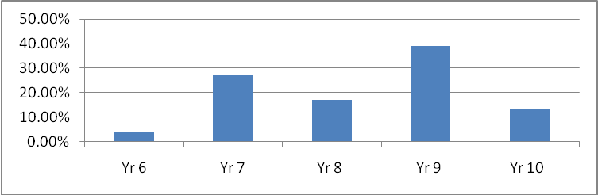
13% of students continued with formal schooling until Year 10 however only 9% had completed the School Certificate.
70% were not attending school.
Of the 30% who were still attending school 19% were attending a behaviour school or tutorial centre.
None were completing Distance Education.

Student attendance
- Attendance rates are relatively static and at 96.6% well above those of the region and State.
- Students are often withdrawn from school to attend a range of non school based commitments.

Student performance
- Students at Induna School are exempt from NAPLAN testing. The majority of students would be below the five minimum standards of NAPLAN domains had they sat for tests in Yrs 7 & 9.
- It is educationally irrelevant and statistically invalid to make comparisons to like school groups or state cohorts for our students.
- In 2009 students had an average age of 16.10, and 95% were well below age appropriate literacy and numeracy benchmarks. Due to varying enrolment periods over which we have no control we have complex and limited windows of opportunity to address deeply entrenched patterns of learning failure.
- 60% of students are aged for HSC studies but their literacy levels are from stages 1 to 3.
- If Norta Norta funding was available to our students they would benefit from Years 6, 8 & 10 tutorial learning assistance; access to an independent learning hub, middle years and senior years tutor, mentor and leadership programs, and, for our years 11 and 12 students, individual sponsorship for tutorial assistance. Unfortunately we cannot access Norta Norta.
- Prior to the Norta Norta program in 2008 the school was able to access tutorial/mentor support under DEEWR funding. Student literacy skills were assessed on enrolment by the Neale diagnostic assessment tool (Neale). 83 students were supported through intensive literacy tutorial support. 24 students were enrolled long enough to be re-assessed and indicated an average reading age increase of 15 months over an average enrolment period of two months.
- The average age at enrolment for 83 students tested with the Neale reading test was 16.16 years, however the average reading age was 10.86 years. All students with age inappropriate literacy skills were provided with literacy support. Students participating for more than five weeks improved an average of seven and a half months for every month on the program; and the highest gain in reading age was 3.3 years over three months.
- In 2010 student literacy needs were assessed on enrolment using a combination of the Lexia Quick Reading Test and the PM Benchmarking kit. Each student was placed on an individualised literacy plan according to identified need. Due to short periods of attendance for many students, reliable value added data has not been gathered. Of the students who were in attendance long enough for subsequent assessments of literacy progress the following results were identified:
- 12 students who engaged regularly in the Lexia reading scheme showed an average improvement rate of one year in every month on the program;
- 21 students whose literacy development was supported by the PM benchmark kit showed an improvement rate of 5.2 months for every month on the program;
- 34 students who engaged in timed reading improved an average rate of 1.8 levels per month; and
- 58 student writing samples were obtained and assessed with the Reading to Learn writing tool, which benchmarks stage appropriate writing scores at a score of 48. The average score for 58 students was 11.84, however of these only 21 attended long enough to have a follow up assessment. The average initial score for these 21 students was 10.95 and their average second score was 13.86, over an average period of 56 days.
- In 2010, students averaged eight weeks before being able to access Vocational Education (VET) courses. 56% students at enrolment indicated they would like to undertake one or more VET courses, however only 24% were able to commence a course. The period taken to access VET courses is longer than previous years, and the number of students able to access VET is lower than previous years. The number of Australian Qualifications Framework (AQF) Certificate credentials is accordingly less than previous years. The number of credentials from AQF Frameworks achieved in 2010, as reported in the Annual School Report will not be known until January 2011.
- In 2009 427 AQF credentials were achieved and students gained Statement of Attainment (SOA), Certificate 1, or Certificate 2 credentials.
Student achievements were:
- Primary Industries Horticulture. Three students achieved Certificate 1 and 12 received a SOA towards Certificate 2. One student achieved Certificate 2. Students achieved a total of 90 AQF credentials;
- TAFE Automotive. Four students completed Certificate 1 while 12 achieved a SOA towards Certificate 2. Two students achieved Certificate 2. Students achieved a total of 104 AQF credentials;
- Furniture Making Furnishing. Two students completed Certificate 1 while 23 achieved a SOA towards Certificate 2. Students achieved a total of 112 AQF credentials;
- 11 students obtained a SOA towards Certificate 1 in OTEN course 9070; and
- In short pre-employment pre-requisite courses 121 AQF credentials were achieved.

Student engagement
- Students with low average literacy skills and a history of behavioural difficulties do not engage well in distance education studies (DE). Over recent years data reveals both engagement and completion rates of DE students are low. Data for 2010 substantiates past findings:
- Nine students undertook DE School Certificate studies and averaged a return rate of 1.86 title pages per week of the required five. None remain enrolled at Induna and it is unknown if they have continued with their studies either through Distance mode or at a school.
- Eight students undertook Preliminary DE studies and averaged a return rate of two title pages of the required three per week.
- Our strategic priority is to deliver as much curriculum as possible to students by Induna teachers utilising the Quality Teaching (QT) framework. The recent recruitment of additional staff with extensive experience in secondary curriculum enables the school to increase the number of classes taught by teachers with deep knowledge and understanding of secondary subject areas. Induna staff agree student learning outcomes are enhanced with pedagogy characterised by direct instruction, and support the strategic move towards reducing where ever possible, reliance on distance mode delivery. The QT matrix scores places pedagogy based on traditional outsourced curriculum in key learning areas at levels 1 and 2.
- A Quality of School Life (QSL) student survey was conducted in August 2010. This is the first year QSL has been used at the school and the mean scale agreement score was 81%.
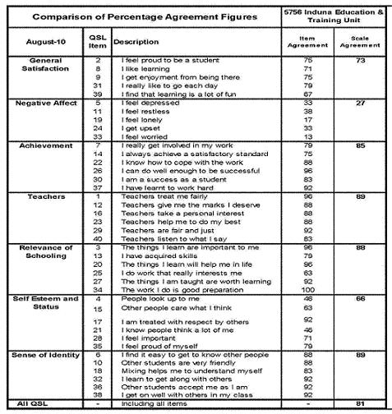
Students expressed an agreement rate for a sense of achievement in what they were undertaking (85%), the way staff supported their efforts (89%), the relevance of schooling to their lives (88%) and their sense of identity while at school (89%).
27% of students expressed indications of depression and anxiety in their lives with 33% indicating they feel depressed or upset and 38% indicating they feel restless.
66% indicated scale agreement with their sense of self esteem and status with 92% indicating they were treated with respect. 42% felt others thought a lot of them.
The general satisfaction scale agreement was 73% with 79% indicating they liked going to school each day while only 67% indicated learning was a lot of fun.
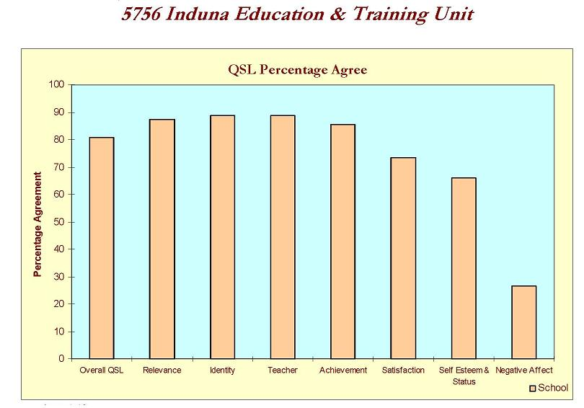
Overall areas of strength with greater than 91% agreement in student responses were:
92% - I have learnt to work hard, Teachers are fair and just, The things I am taught are worth learning, I am treated with respect by others, I learn to get along with others, Other students accept me as I am and I get on well with others in my class.
96% - I can do well enough to be successful, teachers treat me fairly, the things I learn are important to me and the things I learn will help me in life.
100% indicated the work they do is good preparation.
Two areas or concern were that only 63% indicated they do work that really interests them and only 67% reported they find learning to be a lot of fun.
- An analysis of Records of Behaviour (ROBs) up to the end of September 2010 indicates breaches of the rules ‘Follow Staff Instructions and ‘Behave Sensibly and Safely’ are the most frequently breached rules. Over the past three years records of behaviour have indicated a decreasing trend as demonstrated in the chart titled ‘Rule Comparisons Over the Years’.

- An analysis of Behaviour Monitoring sheets for terms 1,2 and 3 indicated.
- An average of 12% of students or 2.8 students were disengaged in one or more subjects each week.
- 14.75% of students failed to earn maximum incentive points each week due to behavioural issues that warranted staff correction.
- Student engagement is affected by mental health issues. The following research conducted by our partner agency provides a profile of mental health issues impacting on engagement. This research is similar to an analysis of guidance file summaries. Managing student psychosocial disorders is an ongoing challenge for teachers engaging students in our learning environment.
- Staff observations over recent years indicate an increase in the number of students with significant mental health issues.
Adolescent Psychopathology Scale %
APS Scales | Mild | Moderate | Severe
Substance Abuse Disorder | 14 | 19 | 27
Conduct Disorder | 4 | 32 | 24
ADHD Disorder | 13 | 14 | 1
Anger/Violence | 8 | 14 | 3
Aggression | 22 | 14 | 11
Posttraumatic Stress Disorder | 8 | 9 | 0
Suicide (ideation or behaviours) | 3 | 1 | 5
Oppositional Defiant Disorder | 8 | 12 | 3
Interpersonal Problems | 26 | 12 | 4
Major Depression | 9 | 3 | 1
Self-concept | 11 | 3 | 0
Bulimia Nervosa | 1 | 3 | 1
Anorexia | 1 | 1 | 0
Generalised Anxiety | 3 | 5 | 1
The Adolescent Pathology Scale (APS) generates 14 scales to describe a range of psychological and psychiatric symptoms warranting possible referral or intervention. Results from this state-wide survey of students in similar schools indicated the following:
- 40% reported severe symptoms on
the APS consistent with a clinical disorder.
- Conduct Disorder (19%) and Substance Abuse Disorder (26%) were the two most prevalent disorders.

- 25% had ‘high’ or ‘very high’ distress scores on the Kessler Psychological Distress Scale, suggestive of a depressive or anxiety related disorder.

- 15% males had intentionally hurt or injured themselves.

- 14% males had considered attempting suicide.

- 8% males had attempted suicide.

- These findings are consistent with Induna School as evidenced by medical and psychological advice and the behaviour management issues staff are addressing in order for teaching and learning to occur.
- Over recent years Induna staff have accessed a range of professional learning courses to support interventions that assist students in managing their mental health issues. Staff have identified there is an ongoing need for further professional learning in this field.
- Strict and consistent boundaries and consistent staff implementation of policies and procedures are essential to support our students in achieving their potential.
Students undertaking Distance Education studies have not achieved basic course requirements.
Title page returns are well below the expected rate and students are inadequately engaged. Our observations are that students with low literacy skills and a history of behavioural difficulties do not engage well in distance education.
Student outcomes are enhanced by pedagogy delivered by our teachers.
There is a need to deliver secondary curriculum within the context of an ever changing student cohort.
Students present with complex challenging behaviours, requiring individualised, targeted social skills and behaviour modification interventions.
The school has made commendable progress in reducing the number of records of behaviour over the past three years

Staff profile
Teaching and support staff collaborate to meet the educational needs of all students, according to identified individual plans. We offer students intensive assistance in all subjects to experience success in learning, and to encourage engagement in a credentialed pathway to an identified educational or vocational goal.
Position | Number
Principal | 1
Head Teachers/Assistant Principal(s) | 3
Classroom Teachers | 6.8
Extended Year Teacher | 1.188
School Administrative Manager | 1
Aboriginal Education Officer | 1
Student Learning Support Officer | 7
General Assistant | 0.4
SASS Extended Year | 0.802
Part Time TAFE teachers | .7
Aboriginal Mentors | .4
Counsellor | 0.08
Total | 23.37

Induna School has had a stable staff over the past ten years however an additional nine staff have joined the team in term 4 2010.
100% of teaching and school administrative support staff were retained from 2007.
As the school cannot access Norta Norta funding part time literacy tutors are funded from global funds to support high support needs students.
Part time TAFE teachers deliver TVET Building and Construction, Automotive and a range of pre-employment short courses.

Professional Learning
- Professional Learning Expenditure in 2010, as in previous years is largely funded from the school global budget. Expenditure on professional learning accounts for 20.9% of the total school budget.
- Priorities in 2010 were:
- Literacy, with an emphasis on Accelerated Literacy;
- Student Engagement and Retention;
- Teacher and Leader Quality with an emphasis on developing teacher knowledge and expertise in Quality Teaching and Positive Behaviour for Learning;
- Aboriginal education with an emphasis on Cultural Awareness; and
- Connected Learning with an emphasis on developing teacher knowledge and expertise to increase capacity to embrace the Digital Education Revolution (DER), and incorporate the DER into our highly constrained ICT context.

FUNDING SOURCE | BUDGET | ACTUAL EXPENDITURE | PERCENTAGE
School Funded PL | 8000 | 13,800 | 56.3%
Digital Education Revolution | 1689.63 | 1689.63 | 6.9%
Beginning Teachers | 2433.55 | 2433.55 | 9.9%
Teacher Professional Learning | 6600 | 6600 | 26.9%
TOTAL | 18723 | 24523.18 | 100

- Areas of professional learning that can be enhanced include:
- 8 Ways of Learning, Cultural Awareness training and specific strategies to enhance engagement and educational outcomes for Aboriginal students;
- leadership development programs for Head Teachers;
- teacher professional learning teams engaging in ongoing school based teacher professional learning in Quality Teaching;
- teacher expertise in digital technologies; and
- building teacher capacity to ensure highly professional interventions for students with complex behaviour and psychosocial support needs.
The delivery of curriculum by Induna teachers utilising the Quality Teaching (QT) framework is complicated by the fact that a number of teachers trained in K-6 do not have deep knowledge and understanding of secondary curriculum.
The recent recruitment of additional staff with extensive experience in secondary curriculum enables the school to increase the number of classes taught by teachers with deep knowledge and understanding of secondary subject areas.
There is agreement among teachers that a move towards direct instruction is in the best interest of our students.
Teachers working on units of work based around common outcome groups based around IWB pedagogy in Stages 4 and 5 found students engaged positively in lessons and learning outcomes were encouraging.
Professional Learning has proven to be most effective when teams of teachers are released to work on common areas of school improvement and engage in action research to address identified needs.
Aboriginal education is embedded in all KLAs and there is a high priority placed on Aboriginal education. Staff expertise in cultural appropriate pedagogy varies and there is a need to raise awareness of culturally appropriate learning styles.

Literacy and Numeracy
- The Literacy Committee reviewed the school’s literacy policy in 2010. Agreement was reached with all teachers on a variety of strategies to address student literacy learning needs. Most students have elementary literacy skills, and none have adequate skills to independently access stage appropriate curriculum with ease. The revised policy recognises the importance of catering for the literacy needs of all students through careful, ongoing assessment and individual programming.
Our student population is characterised by high turnover and this requires teachers to ensure regular monitoring and recording of student progress to enable accurate reports to be available if students move to other locations. Analysis of 2010 literacy records revealed inconsistent recording of literacy data, since the literacy strategy was revised earlier this year.
- Despite agreement on a revised literacy and numeracy policy at the start of 2010 teacher surveys have revealed varying levels of commitment to the implementation of the policies as originally agreed. Different teachers have indicated differing beliefs and priorities for addressing identified student literacy and numeracy learning needs.
- In literacy some prefer to focus on using the Lexia program, others focus almost solely on the PM Benchmarking kit and fast Forward readers, while a few focus on addressing literacy demands in distance mode worksheets. Teachers who have not regularly utilised past professional learning in Accelerated Literacy and Reading to Learn would like refresher training. It appears as though teacher confidence in using software packages such as Lexia is a factor in reluctance to utilise it. A team based approach to staff professional learning in literacy teaching is the focus of school planning for 2011.
- A similar variation occurs in teacher implementation of numeracy programs. A return to specialist teaching of mathematics will occur in 2011.
A number of outcomes were identified in the schools literacy and numeracy data as being strengths and problematic
There is an identified need for ongoing school based teacher professional learning
Individual assessments identify strengths and weaknesses and teachers program to address these.
Low Literacy skill levels prevent some students from accessing all KLA outcomes
Technology
- Most classrooms have Interactive Whiteboards (IWB) installed and computers for student and staff use. All teachers have completed basic IWB training. All teachers are essentially self taught in ICT and demonstrate varying levels of professional ICT competency. Some teachers use ICT equipment in most lessons while others rarely utilise available technologies. To determine the level of confidence and competency in use of ICT, staff completed a survey, which found:
  - 60% of staff request further training in the use of electronic diagnostic tools such as Lexia and Mathspower to inform teaching and programming;
  - 80% of staff believe they need training to increase their knowledge of course-specific software for student use in all KLAs;
  - 100% of staff are knowledgeable and competent in use of the school server to view and display resources and files in their classrooms;
  - 60% of staff have no experience in simple editing and enhancement techniques with movie files;
  - 90% of staff indicate a need for training in creation and use of movie files; and
  - 90% of staff are either unable to use or require further training in use of Smartboard software to save screens and produce visual effects.
Parents/community
- Our parent body moves students at short notice which impacts on student progress, engagement and learning.
- Our parent body withdraws students from VET on the basis of behaviour in residential accommodation. Accordingly student progress, engagement and attitudes to education can be adversely affected in the short term.
- Reviews and reports conducted by our parent body repeatedly indicate a high level of appreciation for the work of staff at Induna School.
- Concerns raised throughout the year by parents included:
- the time taken to complete the enrolment process;
- teacher punctuality;
- difficulties students experience accessing education when they return to their home communities; and
- inconsistencies in teacher enforcement of rules.
- School and community partnerships are characterised by high levels of trust, collaboration and respect. Our partnerships are characterised by a strong commitment towards achieving improved outcomes for our students and the strength of our partnerships provide excellent opportunities to refine and improve systems to support our students.
- Strong partnerships have existed between Induna School and North Coast Institute of TAFE Outreach programs over the past eleven years. This partnership provides valuable AQF courses that deliver credentialed employability skills and assist our students in gaining insight into the world of work.
- In 2010 the school has enjoyed a strong partnership with Bulgarr Ngaru Medical Centre. A joint initiative to improve nutrition and awareness of organic vegetable production has been undertaken throughout 2010 and as a result our students are subsidising their diet with food they have grown.
- Foundations have been built to solidify our partnership with NORTEC Youth Connections who have taken over from TURSA, our previous partner agency, in supporting our students in transition.
- The school enjoys a growing partnership with Mission Australia in supporting our students when they transition from our school.
- Our partnership with the National Network of Educators in Secure Care has continued to grown with three staff participating in three days of tremendously valuable professional learning.

CONCLUSIONS AND RECOMMENDATIONS

Using the findings from section 3, develop conclusions, recommendations and strategies linked to the six Reforms.
Conclusion | Recommendation | Draft strategies to be implemented | Final strategies to be implemented (following joint planning sessions) | NP Reform
The school has identified a need to refine practice to more systematically assess and record literacy and numeracy interventions.  There is an identified need for ongoing school based teacher professional learning  Individual assessments identify strengths and weaknesses and teachers program to address these. | All students have significant literacy and numeracy support needs  The Literacy committee is to ensure it meets at regular intervals under the guidance of a head teacher with responsibility for Literacy teaching and learning.  Teachers are to engage in ongoing school based professional learning to refine A number of outcomes were identified in the schools literacy and numeracy data as being strengths and problematic  and develop deeper knowledge of the Quality Teaching framework  In 2011 the school literacy program is to be further revised in consultation with all teachers.  In 2011 a specialist maths teacher is to assume responsibility for individual mathematic programs | Establish a discreet intensive literacy class.  Timetable a specialist teacher onto mathematics.  Reconstitute the Literacy Committee to meet at regular intervals and to record and use data on an ongoing basis to inform decisions.  Investigate whether efficiencies in data entry can be identified and implemented.  Teachers to engage in team school based professional learning with these focus areas:  - Quality Teaching  - Use of ICT  The school adopt the Quicksmart program.  The school purchases appropriate software packages to address literacy support needs | Establish intensive literacy class.  Reconstitute the Literacy Committee to meet at regular intervals and to record and use data on an ongoing basis to inform decisions.  Teachers to engage in team school based professional learning with these focus areas:  - Quality Teaching  - Use of ICT  Timetable a specialist teacher onto mathematics.  The school adopt the Quicksmart program.  Purchase Reader Write Gold software package to assist literacy support needs | 1  2  3  4  5  6
Low Literacy skill levels prevent some students from accessing all KLA outcomes | Identify ways of minimising the impact of low literacy on achieving KLA course outcomes | Incorporate Read and Write, Gold software into teaching to reduce low literacy from preventing the achievement of KLA outcomes  All literacy teachers undertake professional learning in:  Reading To Learn  Using ICT as a tool for Literacy Teaching Across KLAs  Differentiated Learning in the Secondary Classroom  Quicksmart Literacy | By the end of 2011 ensure all literacy teachers have undertaken professional learning in:  Reading To Learn  Using ICT as a tool for Literacy Teaching Across KLAs  Differentiated Learning in the Secondary Classroom  Quicksmart Literacy | 1  3  4
Students present with complex challenging behaviours, requiring individualised, targeted social skills and behaviour modification interventions.  The school has made commendable progress in reducing the number of records of behaviour over the past three years | That WE ensure all new staff are provided with comprehensive PL on PBL in conjunction with established staff, to ensure a shared vision and common language regarding student behaviour. | Reconstitute the PBL coordination team to include new staff;  analyse existing baseline school data;  re establish core school values;  achieve consensus regarding behavioural expectations across settings;  formulate a three to five year plan for building school student welfare; and  regular explicit teaching of appropriate, expected behaviours | Re establish core school values.  Achieve consensus regarding behavioural expectations across settings.  Formulate a three to five year plan for building school student welfare through PBL.  Regular explicit teaching of appropriate, expected behaviours.  TARS process include evidence of IBSPs. | 1  2  4  5
Students undertaking Distance Education studies have not achieved basic course requirements.  Title page returns are well below the expected rate and students are inadequately engaged. Our observations are that students with low literacy skills and a history of behavioural difficulties do not engage well in distance education.  Student outcomes are enhanced by pedagogy delivered by OUR teachers.  There is a need to deliver secondary curriculum within the context of an ever changing student cohort. | The strategic direction of Induna School is to support Induna teachers in delivering as much curriculum as possible and to rely less on outsourced curriculum. | Students should only access Distance Education when it is beyond the capacity of the school to deliver the identified subject  Revise and develop existing strategies to monitor student engagement and the meeting of title page returns in Distance Education. | Induna School provides programmes in all KLAs and students will only access DE when it is not possible to provide curriculum from within school resources.  Students who must study subjects by DE are to prepare weekly and daily targets and evaluate these with supervising case teachers.  Supervising teachers are to develop a range of motivational strategies to support students studying DE. | 1  2  3  4  5
The delivery of curriculum by Induna teachers utilising the Quality Teaching (QT) framework is complicated by the fact that a number of teachers trained in K-6 do not have deep knowledge and understanding of secondary curriculum.  The recent recruitment of additional staff with extensive experience in secondary curriculum enables the school to increase the number of classes taught by teachers with deep knowledge and understanding of secondary subject areas.  There is agreement among teachers that a move towards direct instruction is in the best interest of our students. | Teachers will need ongoing school and team based professional learning in QT, to identify solutions to the unique challenges of curriculum design, assessment and delivery in this environment. | A Head Teacher is to assume responsibility for leading teachers in developing deep knowledge of QT.  Teachers will work in school based teams to develop our own curriculum for years 7-12. The initial focus will be on Stage 4 & 5 Common Outcome Groups (COGS).  A comprehensive school based PL plan for 2011 will be developed.  Explore the feasibility of implementing the Stage 6 English Content Endorsed Course  (CEC) course.  HT Special Education to lead teachers in including curriculum adjustments into teaching and learning programs and assessment tasks.  Teachers partner with National Network teachers to identify innovative best practice. | Head Teachers (HTs) are to lead teachers in developing deep knowledge of QT.  A HT will lead school based teams to develop Induna curriculum for years 7-12. The initial focus will be on Stage 4 & 5 Common Outcome Groups (COGS).  A comprehensive school based PL plan for 2011 will be developed.  Explore the feasibility of implementing the Stage 6 English Content Endorsed Course (CEC) course.  HT Special Education to lead teachers in including curriculum adjustments into teaching and learning programs and assessment tasks.  Teachers partner with National Network teachers to identify innovative best practice. | 1  2  3  4  5  6

Teachers working on units of work based around common outcome groups based around IWB pedagogy in Stages 4 and 5 found students engaged positively in lessons and learning outcomes were encouraging.  Professional Learning has proven to be most effective when teams of teachers are released to work on common areas of school improvement and engage in action research to address identified needs. | Focus on incorporating IWB & DER technologies into T&L through continuous team based PL.  Support teachers in developing extensive knowledge of DER pedagogies for secondary curriculum. | Provide 60% of staff, training in use of electronic diagnostic tools such as Lexia and Mathspower to inform programming.  Provide 80% of staff training to increase knowledge of course-specific software for student use in all KLAs  Provide 60% of staff training in simple editing and enhancement techniques with movie files.  Provide 90% of staff training in creation and use of movie files.  Provide 90% of staff training in use of Smart board software to save screens and produce visual effects | Provide staff, training in use of Lexia and Mathspower electronic diagnostic tools to inform programming.  Provide staff training:  - to increase knowledge of course-specific software for student use in all KLAs  - in simple editing and enhancement techniques with movie files.  - in creation and use of movie files  - in the use of Smart board software to save screens and produce visual effects | 1  3  4
Aboriginal education is embedded in all KLAs and there is a high priority placed on Aboriginal education. Staff expertise in cultural appropriate pedagogy varies and there is a need to raise awareness of culturally appropriate learning styles. | Teachers are to be provided with professional learning on culturally appropriate pedagogies and catering for diverse learning styles. | School based teams are to be provided with PL on:  - ‘8 Ways of Learning’  - Cultural Awareness Training  - ‘Spoken Language of Young Offenders’  - Language  Agreement is to be reached on how this learning is to be reflected in pedagogy | School based teams are to be provided with PL on:  - ‘8 Ways of Learning’  - Cultural Awareness Training  - ‘Spoken Language of Young Offenders’  - Language  Agreement is to be reached on how this learning is to be reflected in pedagogy | 1  2  3  4  5  6
5.0 SCHOOL PLAN TARGETS 2011
Targets 2011
Increase the percentage of teachers who feel confident developing individual behaviour support plans from 33% to 60%.-
Increase the percentage of students who indicate they do work that really interests them from 63% to 70%.
Increase the percentage of students who indicate they find learning to be a lot of fun from 67% to 75%.
Achieve 70% in all externally assessed SET data through a regular systematic focus on Positive Behaviour for Learning.
Increase the number of classes where quality teaching programmes based on Board of Studies Syllabus 7-12 with embedded curriculum adjustments, are taught by Induna teachers from 60% to 95% in 2011
Increase staff confidence using electronic diagnostic tools like Lexia and Mathspower to inform teaching and programming from 60% to 70%.
Increase the percentage of teachers who regularly use electronic whiteboard technologies to enhance quality teaching from 40% to 70%.
100% teachers are provided with Literacy related professional learning on the use of ICT in teaching and learning.
At the end of Induction all PLPs are to contain literacy and numeracy goals and strategies.
The Quicksmart program will be implemented to support numeracy learning.
Staff surveys indicate growth of one level on the Quality Teaching matrix.
Executive demonstrate a progression in identified leadership capabilities within the School Leadership Capability Framework over 12 months
100% of teachers will integrate interactive technologies for the digital education revolution into everyday classroom pedagogy after accessing professional learning in 2011.
Teachers will access professional learning in ‘8 Ways of Learning’, Cultural Awareness Training, ‘Spoken Language of Young Offenders’ & Gumbaingir language..This professional learning will guide the school Aboriginal Education Committee in developing a policy framework on the inclusion of specific strategies to support Aboriginal students in all teaching programs.

- STRATEGIES 2011 - FUNDED BY NATIONAL PARTNERSHIPS

Key strategy 2011
Build executive leadership capacity through the:
- NSW DET Analytical framework for effective leadership and school improvement in literacy and numeracy
- Team Leadership for School Improvement K-12
Improve student learning outcomes through building teacher capacity to deliver engaging curriculum inclusive of the digital education revolution through team school based professional learning.
Whole school focus on PBL
Build a school culture of ongoing professional growth through an explicit program of school based professional learning focussing on developing engaging Quality Teaching programmes for years 7 – 12
Engage the Literacy committee in ongoing assessment of data to ensure optimal implementation of the agreed literacy strategy.
Introduce Quick Smart, effectively use ICT learning tools & interactive technologies in mathematics & develop formalised Maths PLPs.
School based teams are to be provided with PL on:
- ‘8 Ways of Learning’
- Cultural Awareness Training
- ‘Spoken Language of Young Offenders’
And agreement is to be reached on how this learning is to be reflected in pedagogy in our school.

